Design - Activity Diagrams

A report describing the Activity Diagrams for the Network Appliance Service Utilisation Framework

Version: 1.2

By

Paul Fergus

Supervised by

Dr. Martin Hanneghan and Prof. Madjid Merabti

Networked Appliances Lab
School of Computing and Mathematical Sciences
Liverpool John Moores University

Table of Contents
Table of Contents ii
Table of Figures viii
1 Activity Diagram: Start Device 1
1.1 Description 1
1.2 Issues 1
1.3 Requirements 2
1.4 Goals/Context 2
1.5 Assumptions 3
1.6 Scenario/Steps 4
1.7 Extensions 4
2 Activity Diagram: Connect Device to the Network 6
2.1 Description 6
2.2 Issues 6
2.3 Requirements 6
2.4 Goals/Context 7
2.5 Assumptions 7
2.6 Scenario/Steps 7
2.7 Extensions 8
3 Activity Diagram: Create Device Capability Advertisement 9
3.1 Description 9
3.2 Issues 9
3.3 Requirements 9
3.4 Goals/Context 10
3.5 Assumptions 10
3.6 Scenario/Steps 10
3.7 Extensions 10
4 Activity Diagram: Publish Device Capability Advertisement 12
4.1 Description 12
4.2 Issues 12
4.3 Requirements 12
4.4 Goals/Context 12
4.5 Assumptions 12
4.6 Scenario/Steps 12
4.7 Extensions 13
5 Activity Diagram: Start Service Container 14
5.1 Description 14
5.2 Issues 14
5.3 Requirements 14
5.4 Goals/Context 14
5.5 Assumptions 15
5.6 Scenario/Steps 15
5.7 Extensions 15
6 Activity Diagram: Publish Implementation Services 16
6.1 Description 16
6.2 Issues 16
6.3 Requirements 16
6.4 Goals/Context 16
6.5 Assumptions 17
6.6 Scenario/Steps 17
6.7 Extensions 17
7 Activity Diagram: Create Peer Service Advertisements 18
7.1 Description 18
7.2 Issues 18
7.3 Requirements 18
7.4 Goals/Context 19
7.5 Assumptions 20
7.6 Scenario/Steps 20
7.7 Extensions 21
8 Activity Diagram: Publish Peer Service 22
8.1 Description 22
8.2 Issues 22
8.3 Requirements 22
8.4 Goals/Context 23
8.5 Assumptions 23
8.6 Scenario/Steps 23
8.7 Extensions 23
9 Activity Diagram: Create Semantic Models 24
9.1 Description 24
9.2 Issues 24
9.3 Requirements 24
9.4 Goals/Context 25
9.5 Assumptions 25
9.6 Scenario/Steps 25
9.7 Extensions 26
10 Activity Diagram: Find Core Services 27
10.1 Description 27
10.2 Issues 27
10.3 Requirements 27
10.4 Goals/Context 27
10.5 Assumptions 28
10.6 Scenario/Steps 28
10.7 Extensions 28
11 Activity Diagram: Retrieve Context Templates 29
11.1 Description 29
11.2 Issues 29
11.3 Requirements 29
11.4 Goals/Context 29
11.5 Assumptions 30
11.6 Scenario/Steps 30
11.7 Extensions 30
12 Activity Diagram: Realise Context Template 31
12.1 Description 31
12.2 Issues 31
12.3 Requirements 31
12.4 Goals/Context 32
12.5 Assumptions 32
12.6 Scenario/Steps 32
12.7 Extensions 32
13 Activity Diagram: Discover Peer Service 33
13.1 Description 33
13.2 Issues 33
13.3 Requirements 33
13.4 Goals/Context 33
13.5 Assumptions 34
13.6 Scenario/Steps 34
13.7 Extensions 34
14 Activity Diagram: Invoke Peer Service 35
14.1 Description 35
14.2 Issues 35
14.3 Requirements 35
14.4 Goals/Context 36
14.5 Assumptions 37
14.6 Scenario/Steps 37
14.7 Extensions 37
15 Activity Diagram: Process Service Request 38
15.1 Description 38
15.2 Issues 38
15.3 Requirements 38
15.4 Goals/Context 39
15.5 Assumptions 39
15.6 Scenario/Steps 39
15.7 Extensions 40
16 Activity Diagram: Perform Semantic Interoperability 41
16.1 Description 41
16.2 Issues 41
16.3 Requirements 41
16.4 Goals/Context 42
16.5 Assumptions 43
16.6 Scenario/Steps 43
16.7 Extensions 43
17 Activity Diagram: Extract Ontological Structures 44
17.1 Description 44
17.2 Issues 44
17.3 Requirements 44
17.4 Goals/Context 45
17.5 Assumptions 45
17.6 Scenario/Steps 45
17.7 Extensions 45
18 Activity Diagram: Evolve Ontological Structures 46
18.1 Description 46
18.2 Issues 46
18.3 Requirements 46
18.4 Goals/Context 47
18.5 Assumptions 47
18.6 Scenario/Steps 47
18.7 Extensions 48
19 Activity Diagram: Merge Ontological Structure 49
19.1 Description 49
19.2 Issues 49
19.3 Requirements 49
19.4 Goals/Context 50
19.5 Assumptions 50
19.6 Scenario/Steps 50
19.7 Extensions 50
20 Activity Diagram: Perform Abstract Match 51
20.1 Description 51
20.2 Issues 51
20.3 Requirements 51
20.4 Goals/Context 52
20.5 Assumptions 52
20.6 Scenario/Steps 52
20.7 Extensions 53
21 Activity Diagram: Perform Concrete Match 54
21.1 Description 54
21.2 Issues 54
21.3 Requirements 55
21.4 Goals/Context 55
21.5 Assumptions 55
21.6 Scenario/Steps 55
21.7 Extensions 56
22 Activity Diagram: Build Signature 57
22.1 Description 57
22.2 Issues 57
22.3 Requirements 58
22.4 Goals/Context 58
22.5 Assumptions 59
22.6 Scenario/Steps 59
22.7 Extensions 59
23 Activity Diagram: Find Intermediary Service 60
23.1 Description 60
23.2 Issues 60
23.3 Requirements 61
23.4 Goals/Context 61
23.5 Assumptions 61
23.6 Scenario/Steps 61
23.7 Extensions 61
24 Activity Diagram: Device Capability Matching 62
24.1 Description 62
24.2 Issues 62
24.3 Requirements 62
24.4 Goals/Context 62
24.5 Assumptions 63
24.6 Scenario/Steps 63
24.7 Extensions 63
25 No extensions to the details defined above are known at this stage.Activity Diagram: Encrypt Data 63
25 Activity Diagram: Encrypt Data 63
25.1 Description 66
25.2 Issues 66
25.3 Requirements 66
25.4 Goals/Context 67
25.5 Assumptions 67
25.6 Scenario/Steps 67
25.7 Extensions 67
26 Activity Diagram: Decrypt Data 68
26.1 Description 68
26.2 Issues 68
26.3 Requirements 68
26.4 Goals/Context 68
26.5 Assumptions 69
26.6 Scenario/Steps 69
26.7 Extensions 69
27 References 70

Table of Figures
Figure 1 Start Device 1
Figure 2 Connect Device to the Network 6
Figure 3 Create Device Capability Advertisement 9
Figure 4 Publish Device Capability Advertisement 12
Figure 5 Start Service Container 14
Figure 6 Publish Implementation Services 16
Figure 7 Create Peer Service Advertisements 18
Figure 8 Publish Peer Service 22
Figure 9 Create Semantic Models 24
Figure 10 Find Core Services 27
Figure 11 Retrieve Context Templates 29
Figure 12 Realise Context Template 31
Figure 13 Discover Peer Services 33
Figure 14 Invoke Peer Service 35
Figure 15 Process Service Request 38
Figure 16 Perform Semantic Interoperability 41
Figure 17 Extract Ontological Structures 44
Figure 18 Evolve Ontological Structures 46
Figure 19 Merge Ontological Structure 49
Figure 20 Perform Abstract Match 51
Figure 21 Perform Concrete Match 54
Figure 22 Build Signature 57
Figure 23 Find Intermediary Service 60
Figure 24 Find Intermediary Service 62
Figure 24 Encrypt Data 66
Figure 25 Decrypt Data 68

- Activity Diagram: Start Device

Description
This Activity Diagram illustrates what happens when the device is initially started within this framework. The Activity Diagram is illustrated in Figure 1.
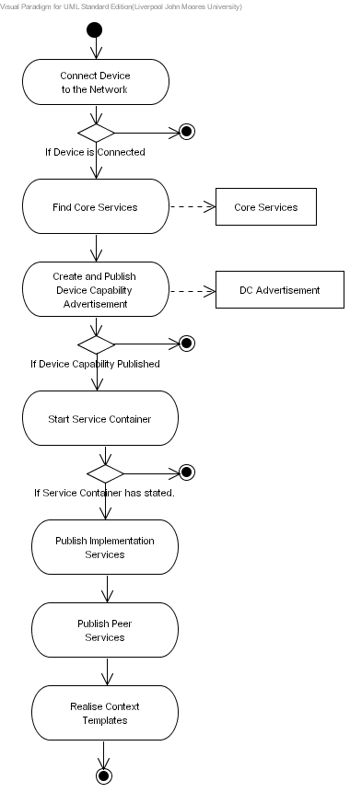
Figure 1 Start Device

Issues
The issues associated with the Activity Diagram are not known at this stage.

Requirements
When a device is switched on it must connect itself to the P2P network – if the device is unable to connect then the boot sequence must terminate and the device must remain in a non-operational state. If the device successfully connects to the network it must discover all the required core Peer Services and bind to them. These services may reside locally or remotely within the P2P network. For each core Peer Service that is discovered a core service object must be created.
Once all the core services have been discovered and bound to the device must create a Device Capability Advertisement, which must describe the hardware, software and networking capabilities the device supports. Within this function mechanisms must be implemented that allow the device to reflect on its internal capabilities, which must be described in the Device Capability Advertisement. If the device fails to determine the capabilities it supports then the device must remain in a non-operational state. The Device Capability Advertisement must be serialised as an advertisement and published locally and remotely within the P2P network. When the advertisement has been published the implementation services used to bind to each Peer Service the device provides must be created. For each implementation service created, it must be published in the service implementation container – this function is dependent on the service technology being used. Each implementation service used by the device must result in an implementation service object. Using implementation services within this framework is not mandatory and is only designed to form a level of abstraction that allows different service technologies to be used.
If the device manufacturer choices not to use implementation services then the service logic must be placed within a Peer Service. In this instance the device will create and publish each application specific peer service the device uses. Again this results in an application specific Peer Service object being created for each application specific Peer Service used by the device.
The final stage requires the device to retrieve the Context Templates it has that describes how the device and its services can be used. Context Templates guide the composition of services and for each service used in a context an application specific Peer Service must be created, if it doesn’t already exist.

Goals/Context
Within this Activity Diagram there are a number of goals that need to be addressed, which are described below.
- Connect Device to the network: When the device is initially switched on it must be connected to the network before it can publish and discover services. If the device cannot connect to the network then it must remain non-operational until the network connectivity error has been rectified – in this instance the device will not be able to publish, discover or use any Peer Services.
- Find Core Services: Devices are required to discover and bind to core services before they can effectively operate within the P2P network. The device may choice to implement some, all or none of these services. Services that are explicitly implemented by the device can be directly used and services that are not explicitly implemented must be discovered remotely and bounded to within the P2P network.
- Create and Publish Device Capability Advertisement: Each device must advertise the capabilities it supports, such as hardware, software and networking capabilities. This must result in a Device Capability Advertisement. If the device fails to successfully advertise it capabilities then an assessment of how effective it can execute the services it provides cannot be determined. Consequently the device must remain non-operation until the error has been rectified.
- Create and Publish Implementation Services: Devices may use implementation services that reside either locally on the device itself or remotely within the P2P network. The type of services used by devices may differ and within this framework they can co-exist – for example Web Services, RMI and CORBA services can be used simultaneously. These services are abstracted away using bindings to generic peer services, which provide a level of flexibility that allows implementation services to be changed to integrate legacy and new service specifications as and when they emerge. If implementation services are used the device must loop through each service and publish it within the service container. In this instance how a service is published is dependent on the service technology being used. Device manufacturers may choice not to support implementation services and in this instance the service logic must be placed in an application specific Peer Service.
- Create and Publish Peer Services: Peer Services provide a generic interface that allow implementation services to be invoked (if implementation services are used – if they are not used then the methods within the Peer Service must be invoked). The device must loop through each peer service used by the device and create a Peer Service object. Once the Peer Service objects have been created they must be published locally and remotely within the P2P network. Devices may choose not to provide implementation or Peer Services but rather they may just wish to use services within the network – because of its limited resources it may not be capable of providing any services. In this instance the device will not create or publish any application specific Peer Services of its own.
- Realise Context Templates: Devices may be used in numerous contexts, which require several other services before they can effectively work. For example a DVD player cannot be used on its own – it requires audio speakers and a visual display. A DVD player that works in this context may be described as a Home Entertainment Theatre System. Consequently a device will have zero or more contexts that describe how the device may be used and what services are required to realise that context. As such the device must discover all the required application specific Peer Services needed within a particular Context Template. This must result in several application specific Peer Service objects, which are explicitly bound to the semantic hooks that exist within the Context Template.

Assumptions
The assumption within this Activity Diagram is that Public Key infrastructures and Digital Certificates are used for authentication and data encryption and decryption. However the framework provides generic interfaces that allow any security model to be overridden and implemented by device manufacturers.

Scenario/Steps
When the device is switched on it must execute a bootstrap routine that connects it to the P2P network. When this routine connects the device to the network it returns a Boolean value indicating the connection status. If the device fails to connect then the bootstrap routine will exit and the device will remain in a non-operation state until the error is rectified. If the device is successfully connected the device calls a routine to create and publish the Device Capability Advertisement. If the device advertisement is successfully create, this results in a Device Capability Advertisement object. This object is serialised and distributed locally and remotely within the P2P network. If this object cannot be created or the advertisement cannot be published the bootstrap routine must exit and the device must remain in a non-operation state until the error is rectified – devices can only participate if the capabilities they provide have been published. This allows other devices to determine whether the device is capable enough to execute the services it provides. Furthermore it allows devices to select services from devices that are the most capable, which ensures that the highest quality of service is maintained.
When the device has published its capabilities a routine must be executed that allows all the implementation services used by the device to be created and published. The device will load a descriptor file that lists all the implementation services – the device will iterate through this list and create and publish each implementation service it discovers. If no implementation services are used the device must exit this routine and execute a routine to create and publish the Peer Services used by the device. Again the device will load a descriptor file that describes all the Peer Services used by the device, which also describes how the Peer Service is bound to its associated implementation service – this only applies if the device uses implementation services, if not then no binding will be required as the logic will be in the Peer Service itself.
The device must also execute a routine to discover all the required core services used within the framework. The device will try to discover the services locally within its service advertisement cache or remotely within the P2P network. If the core service is implemented by the device the relevant core service object will be created. If the core service is not explicitly implemented by the device then a remote service must be discovered within the P2P network and bound to.
When all the core services have been discovered and bound to the device must execute a method that allows all the required application specific Peer Services to be discovered and bound to all the semantic hooks defined in the Context Templates the device supports. If a Context Template has all its semantic hooks bound then the it must be marked as enabled – this means that all the required services needed to execute the Context Template have been discovered.

Extensions
This framework provides a level of flexibility that allows Peer Services to form an abstraction that maps to any implementation service technology the device manufacturer or organisation uses. However there may be instances whereby only the Peer Service can be used. For example such service technologies as Web Services and RMI are transactional and although this may not pose a problem in some situations it may in others – one example may be streaming large amounts of video and audio data. In this instance the action is not transactional – data streams need to be opened and maintained whilst the data is being transferred or broadcasted. Therefore it may be easier to stream the data directly to a Peer Service without using a secondary implementation service. This scenario is not set in concrete and device manufacturers may decide to stream data to an implementation service via a Peer Service in order to maintain the level of abstraction.
Provisions need to be made that describes how the Context Templates are managed. It is highly likely that services will unexpectedly become unavailable for a variety of reasons, the most obvious being the device disconnects from the P2P network, taking all the services it provides with it.

Activity Diagram: Connect Device to the Network

Description
This Activity Diagram illustrates how devices connect to the network within this framework. The Activity Diagram is illustrated in Figure 2.
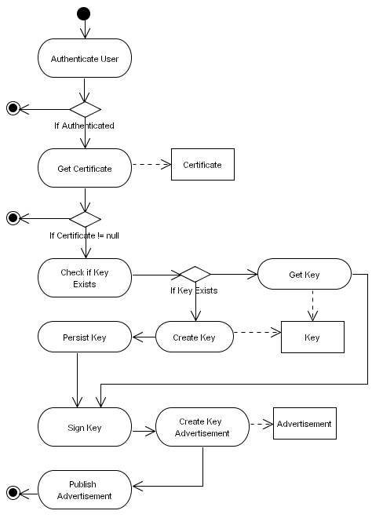
Figure 2 Connect Device to the Network

Issues
The issues associated with the Activity Diagram are not known at this stage.

Requirements
When a device connects itself to the P2P network it must authenticate itself. The framework does not place any constraints on how this is achieved, however it is envisaged that the conventional username and password mechanism will be used. Devices will, in some cases, not have a user interface so authentication must be performed automatically. Consequently the user credentials must be retrieved from the devices persistent storage – mechanisms must be provided to secure these credentials. If the device cannot authenticate itself on the network then this procedure must be terminated and the device must remain in a non-operational state until the correct credentials are provided. If the device successfully authenticates itself if must get a certificate, which must be used to digitally sign data within the system. Again the framework does not place any constraints on how the certificate is obtained – the device could be its own certification authority or a third part authority could be used. If the device is unable to obtain a certificate then it must terminate this process and remain in a non-operational state until the error is rectified.
If a certificate is obtained the device must check to see if it has a private key. If the key already exists it must be retrieved from the devices persistent storage otherwise a new key must be created. When a key is retrieved or created this must result in a private key object. The corresponding public key must be retrieved, serialised and digitally signed using the devices certificate. The serialised public key is then inserted in a public key advertisement and propagated locally and remotely within the P2P network. The devices certificate and the public key infrastructure must ensure that all data transferred between peers is secure – this may be achieved using a number of schemes, one being TLS [7] – the type of security scheme used is left to the device manufacturer.

Goals/Context
Within this Activity Diagram there are a number of goals that need to be addressed, which are described below.
- Authenticate User: Before the device can connect to the network it must successfully authenticate itself. How the device authenticates itself is left to the device manufacturer.
- Get Certificate: Certificates are required within the framework to digitally sign data and messages sent between peers within the network to verify who has sent the data. How certificates are obtained is left to the device manufacturer.
- Check/Create/Persist Public/Private Key: Data encryption and decryption will be based on Public Key infrastructures. The device must check whether it has keys in its persistent storage; if the keys exist they must be retrieved otherwise they must be created and persisted.
- Digitally Sign Public Key: The public key will be propagated within the P2P network and before this task is performed the device must ensure that the key is digitally signed using the devices certificate.
- Create Public Key Advertisement: When the public key has been serialised and digitally signed it must be inserted into a public key advertisement.
- Publish Public Key Advertisement: The public key advertisement must be propagated locally and globally within the P2P network.

Assumptions
The assumption within this Activity Diagram is that Public Key infrastructures and Digital Certificates are used for authentication and data encryption and decryption. However the framework provides generic interfaces that allow any security model to be overridden and implemented by device manufacturers.

Scenario/Steps
In this Activity Diagram the device needs to authenticate itself automatically on the P2P network. How the device performs this function is left to the device manufacturer. However we envisage that the device will use a conventional mechanism such as a username and password. There will typically be no user interface for devices therefore the authentication credentials must be retrieved from some secure persistent storage on the device. If the device cannot be successfully authenticated this procedure will exit and the device will remain in a non-operational state. When the device has authenticated itself it will get the certificate it uses to identify itself – again how this is achieved is left to the device manufacturer. If the certificate cannot be obtained then this procedure will exit and the device will remain in a non-operational state until the error is rectified. If the certificate is successfully obtained the device will check to see if it has a public and private key persisted on the device. If the keys exist they are retrieved otherwise they are created. This will result in public and private key objects being created. The certificate is used to digitally sign the public key, which is then serialised and inserted into a public key advertisement. This advertisement is then propagated locally and remotely within the P2P network.

Extensions
Further analysis is required for the security within this framework to ensure that it provides the most secure mechanisms without impeding on the overall performance of the system. This is important because security may require significant computational processing, which some devices may not have the capabilities to perform. Consequently device capabilities need to be taken into account and security mechanisms adapted accordingly. Furthermore, due to the limitations associated with PKI we may need to consider trust within the P2P network and determine whether certification authorities and public key infrastructures are effective enough.

Activity Diagram: Create Device Capability Advertisement

Description
This Activity Diagram illustrates how a Device Capability Advertisement is created within this framework. The Activity Diagram is illustrated in Figure 3.
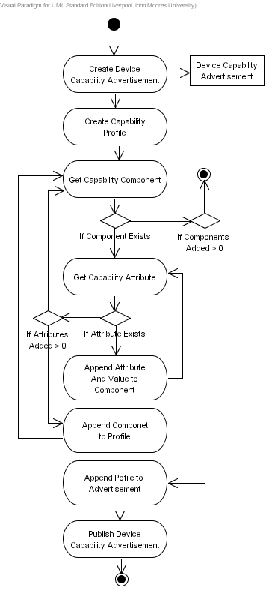
Figure 3 Create Device Capability Advertisement

Issues
The issues associated with the Activity Diagram are not known at this stage.

Requirements
Each device must describe the hardware, software and networking capabilities it supports and publish them locally and remotely within the P2P network. The framework does not place any constraints on how this is achieved and the device manufacturer can either load this from some persisted device capability description file or the descriptions can be hard coded within the logic. This advertisement enables other devices that to determine whether the device supports the required hardware software and networking capabilities to effectively execute the service. Device manufacturers can also add application specific capability descriptions they feel are important. The device must create a Device Capability Advertisement, iterate through all the capability descriptions and append them to this advertisement. When all the capability descriptions have been collected and appended to the advertisement, this object must be serialised and published within the P2P network.

Goals/Context
Within this Activity Diagram there are a number of goals that need to be addressed, which are described below.
- Create Device Capability Advertisement: The device must create a new Device Capability Advertisement.
- Get Capability Description: All the hardware, software and networking capability descriptions need to be extracted. This can either be achieved by processing a descriptor file directly or they can be obtained via getter methods. The descriptor file itself may be loaded from the devices persistent storage – if this file is not being used then the values can be hard coded within the framework logic itself.
- Append Capability Description to Advertisement: Each of the capability descriptions retrieved must be inserted into the Device Capability Advertisement.
- Publish Device Capability Advertisement: When all the capability descriptions have been inserted into the Device Capability Advertisement, the advertisement must be published locally and remotely within the P2P network.

Assumptions
It is the device manufacturers’ responsibility to ensure that the capability descriptions conform to some specification – for example if CC/PP [8] is used then the device manufacturer must ensure that the capability descriptions are valid CC/PP descriptions. The device capability advertisement must be serialised to a RDF(S)-based format. We do not place any constraints on the vocabulary used to describe the individual capability descriptions as the semantic interoperability mechanism implemented in this framework will resolve terms that are syntactically distinct but semantically equivalent.

Scenario/Steps
This process begins by creating a new Device Capability Advertisement, which it uses to describe the capabilities the device supports. This process gets the hardware, software and networking capability descriptions. Each capability description that is retrieved is inserted into the Device Capability Advertisement. In this instance the getter method may return an array of capability descriptions – this process iterates through this collection and performs the insertion. When all the capability descriptions have been inserted into the Device Capability Advertisement, the advertisement is published locally and remotely within the P2P network.

Extensions
The Device Capability Advertisement may be used to discover and locate software packages implemented on a device such as codec’s for different media formats. Although this advertisement is not specifically designed for this purpose, it is possible within this framework to use the Device Capability Advertisement to first see what software is available before a software request is propagated within the P2P network.

Activity Diagram: Publish Device Capability Advertisement

Description
This Activity Diagram illustrates how implementation services are published within this framework. The Activity Diagram is illustrated in Figure 4.
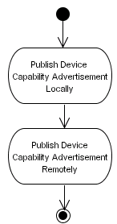
Figure 4 Publish Device Capability Advertisement

Issues
The issues associated with the Activity Diagram are not known at this stage.

Requirements
When the Device Capability Advertisement has been created it must be published locally and remotely within the P2P network.

Goals/Context
Within this Activity Diagram there are a number of goals that need to be addressed, which are described below.
- Publish the Device Capability Advertisement Locally: The Device Capability Advertisement must be published within the devices local cache. How this cache is implemented is left to the device manufacturer.
- Publish the Device Capability Advertisement Remotely: The Device Capability Advertisement must be published remotely within the P2P network. How this is achieved is dependent on the P2P technology being used and is left to the device manufacturer.

Assumptions
Advertisements must be associated with other advertisements the device publishes using Globally Unique IDs (GUIDs). This framework does not place any constraints on how this is achieved; however each device and the advertisements it publishes must be explicitly related.

Scenario/Steps
When the device capability advertisement has been created the peer publishes the advertisement locally within the devices cache and remotely within the P2P network.

Extensions
All the advertisements a device publishes must be explicitly related using GUIDs – this allows specific advertisements to be discovered using the GUID extracted for the current advertisement being processed.

Activity Diagram: Start Service Container

Description
This Activity Diagram illustrates how the service container is started within this framework. The Activity Diagram is illustrated in Figure 6.
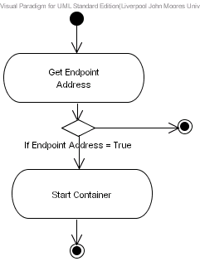
Figure 5 Start Service Container

Issues
The issues associated with the Activity Diagram are not known at this stage.

Requirements
Before implementation services are published the communication endpoint address must be extracted and used when the service container is started. For example if the service technology being used is based on Web Services [9], the Service Container being used is GLUE [10] and the underlying communication protocol is TCPIP then the IP address and the Port must be extracted and used to start the service container – when the service container is started it can be located using the extracted IP address and Port number.

Goals/Context
Within this Activity Diagram there are a number of goals that need to be addressed, which are described below.
- Get Endpoint Address: The endpoint address points to the location of the Service Container. This is an address that allows the services provided by the service container to be accessed. How this is achieved is dependent on the service technology being used and the underlying communication protocol.
- Start Implementation Server: A service container will contain a number of services. The container provides a means of addressing services and publishing them to the outside world. Typically these services will reside in a service container. As such the service container must be started before services can be published.

Assumptions
The device manufacturer will decide what implementation services the device will use, if any, and ensure that the interfaces are maintained and supported by the Peer Services they bind to. The device manufacturer will decide how the endpoint address is constructed depending on the service technology being used and the underlying communication protocol.
We have also assumed that implementation services are objects, which will be published within service containers such as GLUE, Tomcat or Jini. This may not be the case and some other service mechanism may be used. However we assume that services are objects and that these service objects need to be contained within some environment that allows they to be addressed discovered and invoked.

Scenario/Steps
This procedure begins by extracting the endpoint address – how this is achieved is dependent on the underlying communication protocol being used by the device. When the endpoint address has been extracted it is used to start the service container. Again the framework does not place any constraints on what service container is implemented and is solely dependent on the service technology being used.

Extensions
How implementation services are implemented and published is dependent on the service technology being used and how this is achieved is left to the device manufacturer. This framework advocates the use of implementation services to ensure abstract Peer Services are bound to concrete implementations and thus providing a greater deal of flexibility because any service technology can be used. Furthermore this will allow different service technologies to be seamlessly interconnected irrespective of the service technology being used because communication between these services is achieved using Peer Service interfaces.

Activity Diagram: Publish Implementation Services

Description
This Activity Diagram illustrates how implementation services are published within this framework. The Activity Diagram is illustrated in Figure 6.
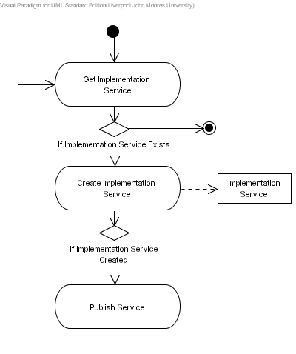
Figure 6 Publish Implementation Services

Issues
The issues associated with the Activity Diagram are not known at this stage.

Requirements
Once the service container has been started, each implementation service needs to be created and published within the container. For example, if Web Services are being used and the underlying communication protocol is based in TCPIP then the IP address and Port number including a unique name that describes the service in a HTTP URL will be used, i.e. http://someip:someport/glue/ws/audio.wsdl. This is only one particular mechanism for defining an endpoint which is dependant on the service technology being used – this decision is left to the device manufacturer.

Goals/Context
Within this Activity Diagram there are a number of goals that need to be addressed, which are described below.
- Get Implementation Service: There is no set requirement for this method; however we envisage that this will take the form of a descriptor file that allows service objects to be located and published within the service container. This task could also be based on the concept of dynamic plug-ins whereby the device automatically includes service objects on start-up. The framework does not place any constraints on how this should be achieved and this decision is left to the device manufacturer.
- Create Implementation Service: When implementation service objects are included within the framework, instances of these objects must be created so that they can be used by core and application specific Peer Services. These services will not be directly invoked but bound to Peer Services and invoked via the Peer Service itself.
- Publish Implementation Service: Once a service instance has been created it must be published so that it can be located and used by a particular Peer Service.

Assumptions
We have assumed that implementation services are objects, which are published within service containers such as GLUE, Tomcat or Jini. This may not be the case and some other service mechanism may be used. However we assume that services are objects that that these service objects need to be contained within some environment that allows they to be addressed discovered and invoked.

Scenario/Steps
When the service container has been started each of the implementation services used by the device are created and published within the service container.

Extensions
No extensions to the details defined above are known at this stage.

Activity Diagram: Create Peer Service Advertisements

Description
This Activity Diagram illustrates how Peer Service Advertisements are created within this framework. The Activity Diagram is illustrated in Figure 7.
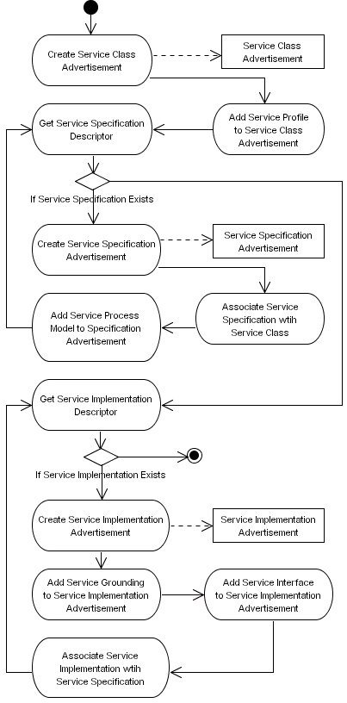
Figure 7 Create Peer Service Advertisements

Issues
The issues associated with the Activity Diagram are not known at this stage.

Requirements
For each Peer Service the device offers, it must create three service advertisements – the Service Class Advertisement, the Service Specification Advertisement, and the Service Implementation Advertisement. A Peer Service must only have one Service Class Advertisement which must advertise a particular behaviour the device wishes to share in terms of its capabilities using a Service Profile Model. The Peer Service must also have one or more Service Specification Advertisements which describe how devices bind to the service including the Atomic and Composite processes the service provides using a Service Process Model – this advertisement is primarily used to access the service and map abstract methods to concrete bindings in the Service Interface. Each Service Specification Advertisement a Peer Service uses must be uniquely defined and linked to the Service Class Advertisement. For each Service Specification Advertisement there must be an associated Service Implementation Advertisement which describes how the Service Specification is implemented – there may be multiple implementations for one Service Specification. The Service Implementation Advertisement must be uniquely defined and explicitly linked to a Service Specification using its unique ID. The Service Grounding Model and the Service Interface must be added to the Service Implementation Advertisement. The Atomic Processes in the Service Process Model must be explicitly mapped onto the Atomic Processes defined in the Service Grounding Model, which themselves must map onto concrete bindings in the Service Interface. The Service Grounding Model and the Service Interface describe how the methods the service provides must be invoked.

Goals/Context
Within this Activity Diagram there are a number of goals that need to be addressed, which are described below.
- Create Service Class Advertisement: The device must create a Service Class Advertisement for each Peer Service it has. The framework does not place any constraints on how this process is achieved – an object can be created from a serialised file for example or a hard coded object can be created. A Service Profile Model must be added to this advertisement that allows peer services to be discovered based on their capabilities rather than attribute-value matching.
- Create Service Specification Advertisements: A Peer Service must have one or more Service Specification Advertisements. This advertisement must be associated with the Service Class Advertisement. Again the framework does not place any constraints on how this is achieved – an object can be created from a serialised XML file or a hard coded object can be created.
- Associate a Service Specification Advertisement with a Service Class Advertisement: A Peer Service must have a Service Specification that describes how the service can be accessed. A Peer Service may have many Service Specification Advertisements; consequently each advertisement must be associated with a Service Class Advertisement via its unique ID. The framework does not place any constraints on how this advertisement is created – an object can be created from a serialised XML file or it can be hard coded.
- Add Service Process Model to the Service Specification Advertisement: A peer service must describe the methods it supports semantically in terms of Atomic and Composite processes. These descriptions must be advertised by inserting the Service Process Model into the Service Specification Advertisement.
- Create Service Implementation Advertisement: Each Service Specification Advertisement must have an implementation. This requires that a Service Implementation Advertisement needs to be created for each Service Specification used. A Service Implementation Advertisements describes how the Service Specification is implemented.
- Add the Service Grounding Model to the Service Implementation Advertisement: In the Service Specification Advertisement the Service Process Model describes the Atomic Processes the Peer Service supports that must be mapped onto the atomic processes described in the Service Grounding Model, which themselves map onto concrete service signatures in the Service Interface. Consequently the Service Grounding Model must be added to the Service Implementation Advertisement to link the semantics of the Peer Service together. The Service Grounding Model states how the service methods are invoked for that particular service implementation, whether the service technology is based on Web Services, RMI or CORBA.
- Add the Service Interface to the Service Implementation Advertisement: The Service Grounding Model contains Atomic Processes that link to the Service Interface therefore the Service Interface must be added to the Service Implementation Advertisement that allows the semantic descriptions to be mapped onto concrete signatures in the Service Interface. The Service Interface defines the implementation depending on what service technology is being used. The specification that describes the service technology will be contained in the relevant Service Specification Advertisement.
- Associate Service Implementation with a Service Specification Advertisement: A Service Specification may have many implementations therefore each Service Implementation must be explicitly associated with a Service Specification Advertisement via its unique ID.

Assumptions
This Activity Diagram assumes that service advertisements are described using an RDF(S) based ontology language. This is the base requirement, however we assume that more expressive ontology languages will be used such as DAML+OIL or OWL - this decision is left to the device manufacturer.

Scenario/Steps
The device begins by creating a Service Class Advertisement containing semantic descriptions that describe the behaviours a particular Peer Service provides. The device will semantically describe these capabilities using a Service Profile Model, which is inserted into the Service Class Advertisement. The Service Class Advertisement will allow the Peer Service to be semantically discovered at an abstract level in terms of the Inputs, Outputs, Preconditions and Effects’ the service supports. When this advertisement has been created the device will create one or more Service Specification Advertisements. Each Service Specification Advertisement is associated with a Service Class Advertisement. A Service Process Model is added to this advertisement, which describes the Atomic and Composite Processes the service supports. Each Service Specification can have one or more Service Implementation Advertisements, which contain the Service Grounding Model and the Service Interface. The Service Grounding Model describes Atomic Processes, which are associated with the Atomic Processes described in the Service Process Model contained within the Service Specification Advertisement, and concrete bindings found in the Service Interface. When a Service Interface Advertisement is created it is explicitly associated with a Service Specification Advertisement via its unique ID. When these three advertisements have been created and published the Peer Service and its associated implementation service (if implementation services are being used) are semantically described and published within the P2P network.

Extensions
The Service Class Advertisement does not only advertise the existence of the service but it also allows all the service specifications to be collected and explicitly associated with a particular type of service using the ServiceClassID. The Service Specification Advertisement also brings with it confusion and it may be argued that only one specification is required. However this limits the flexibility of the framework as a whole. The framework must be flexible enough to incorporate multiple communication protocols and furthermore the implementation of these protocols must not be constrained to one particular standard. Consequently devices must describe the communication specifications they support and the various implementations of those specifications they provide. This will allow other devices within the network to make decisions regarding what services they wish to discover including the choice of specific specifications and their associated implementations.

Activity Diagram: Publish Peer Service

Description
This Activity Diagram illustrates how Peer Services are published within this framework. The Activity Diagram is illustrated in Figure 8.
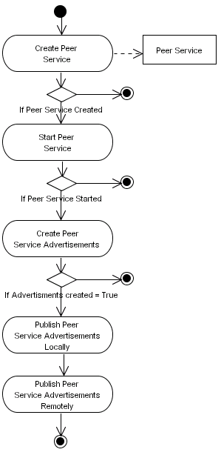
Figure 8 Publish Peer Service

Issues
The issues associated with the Activity Diagram are not known at this stage.

Requirements
This procedure must begin by creating and starting a Peer Service. If the Peer Service cannot be created then this procedure must terminate and the Peer Service must be marked as unusable. If the Peer Service is successfully created it must be started – if the service cannot be started then this procedure must terminate and the Peer Service must be marked as unusable. When the Peer Service has started all the required Peer Service advertisements (Service Class Advertisement, Service Specification Advertisements and the Service Implementation Advertisements) must be created. Calling the Create Peer Service Advertisements results in a collection of advertisement objects being returned – if this collection is not empty then each of the advertisements must be published locally within the devices cache and remotely within the P2P network. Once the Peer Service has been created and started and all its associated service advertisements have been successfully published, the Peer Service is active and ready to be discovered and used by other devices.

Goals/Context
Within this Activity Diagram there are a number of goals that need to be addressed, which are described below.
- Create Peer Service: Before a Peer Service can be published the device must first create it. If the Peer Service cannot be created then the service must be marked at unusable.
- Start Peer Service: When a Peer Service has been created it must be started so that it can be discovered and used by devices within the P2P network. If the service cannot be started for some reason, it must be marked as unusable.
- Create Peer Service Advertisements: At this stage the Peer Service has been created and started, however devices are not aware of its existence until the service is advertised. Consequently all the required advertisements needed to successfully advertise the services existence must be created.
- Publish Peer Service Advertisements Locally: When all the required service advertisements have been created they must be published locally so that the device can discover and use them when required.
- Publish Peer Service Advertisements Globally: Publishing advertisements locally only allows the device that provides the service to discover and use them therefore the service advertisements must be published remotely within the P2P network so that the service can be discovered and used by other devices within the P2P network.

Assumptions
This Activity Diagram assumes that the semantic service advertisements are described using an RDF(S) based ontology language. This is the base requirement, however we assume that more expressive ontology languages will be used such as DAML+OIL or OWL - this decision is left to the device manufacturer.

Scenario/Steps
For each of the Peer Services offered by the device, this procedure first creates the Peer Service and starts it so that it can be used. Once the Peer Service has been successfully created and started, this procedure creates all the required service advertisements that advertise the services’ existence and semantically describes the capabilities it supports using service ontologies. When each of the service advertisements has been created they are published locally and remotely within the P2P network.

Extensions
No extensions to the details defined above are known at this stage.

Activity Diagram: Create Semantic Models

Description
This Activity Diagram illustrates how semantic models are created within this framework. The Activity Diagram is illustrated in Figure 9.
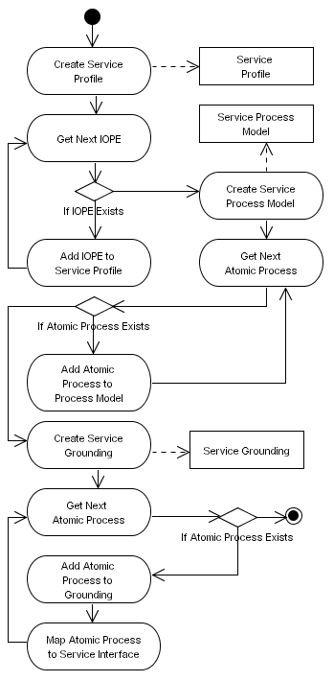
Figure 9 Create Semantic Models

Issues
The issues associated with the Activity Diagram are not known at this stage.

Requirements
This procedure must create all the semantic descriptions used to describe the Per Service – these descriptions are the Service Profile Model, Service Process Model and the Service Grounding Model. The Service Profile needs to be created and each of the IOPEs used to describe the Peer Service need to be added to profile. When all the IOPEs have been added the Service Process Model needs to be created and each of the Atomic Processes the Peer Service supports must be added to the Service Process Model and related to the IOPEs described in the Service Profile Model. When all the Atomic Process have been added the Service Grounding Model needs to be created and all the Grounding Atomic Processes need to be added to it and related to the Atomic Processes in the Service Process Model. The Grounding Atomic Processes must also be mapped onto concrete service signatures defined in the Service Interface.

Goals/Context
Within this Activity Diagram there are a number of goals that need to be addressed, which are described below.
- Create Service Profile Model: The Service Profile Model must be created and used to describe the service in terms of its capabilities. The service’s capabilities must be described using Inputs, Outputs, Preconditions and Effects, which are known as IOPEs.
- Add IOPEs to the Service Profile Model: Each IOPE that is defined must be added to the Service Profile Model.
- Create Service Process Model: The Service Process Model must be created and used to define a semantic representation of the signatures described in the Service Interface.
- Add Atomic Process to the Process Model: Each service signature will have a corresponding Atomic Process – this is an abstract semantic representation of the signature which must be added to the Service Profile Model and mapped onto the IOPEs defined in the Service Profile Model.
- Create Service Grounding Model: The Service Grounding Model must be created in order to bind the abstract semantic layer to the concrete signatures defined in the Service Interface.
- Add Grounding Atomic Processes to the Service Grounding Model: The Grounding Atomic Processes must be added to the Service Grounding Model and mapped onto the Atomic Processes defined in the Service Process Model.
- Map Grounding Atomic Processes to Signatures in the Service Interface: The Grounding Atomic Processes must be directly mapped onto the signatures described in the Service Interface.

Assumptions
The assumption within this Activity Diagram is that the semantic service descriptions are described using a RDF(S) based metadata language. An Ontology needs to be used in conjunction with a Semantic Interoperability Bridge to resolve conflicts between different vocabularies.

Scenario/Steps
This process begins by creating a Service Profile Model. It iterates through all the IOPEs used to describe the Peer Service and adds them to the Service Profile Model. When this is complete a Service Process Model is created and the required Atomic Processes are added to the Service Process Model and associated with each of the IOPEs defined in the Service Profile Model. Once the Service Process Model has been created the Service Grounding Model is created and the required Grounding Atomic Processes are added to it. Each Grounding Atomic Process is associated with an Atomic Process in the Service Process Model and a concrete signature defined in the Service Interface.

Extensions
No extensions to the details defined above are known at this stage.

Activity Diagram: Find Core Services

Description
This Activity Diagram illustrates how core services are discovered within this framework. The Activity Diagram is illustrated in Figure 10.
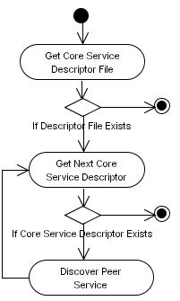
Figure 10 Find Core Services

Issues
The issues associated with the Activity Diagram are not known at this stage.

Requirements
The device must load a descriptor file or hard code the descriptions within the framework logic that describes each of the core services required within the framework to successfully connect it to the network – this decision is left to the device manufacturer. This process must then iterate through the core service descriptors and discover corresponding Peer Services within the P2P network – this process iterates through the core service descriptors until no more core service descriptors are left. If the core service descriptors do not exist this procedure must exit and the device must remain in a non-operation state until the error has been rectified.

Goals/Context
Within this Activity Diagram there are a number of goals that need to be addressed, which are described below.
- Get Core Service Descriptor File (if it exists): When the device starts and after the pre-initialisation procedures have been completed as described in previous Activity Diagrams the device must load the Core Service Descriptor file. The framework does not place any constraints on how this is achieved – i.e. this file could be loaded from the devices persistent storage or it could be described within the code itself.
- Get Next Core Service Descriptor: Core service descriptors must be extracted and iterated through until they have all been processed.
- Discover Peer Service: For each of the core service descriptors, a corresponding core Peer Service must be discovered within the P2P network.

Assumptions
The assumption is that each core service used must be described in a descriptor file. We have described the four core services that are needed within this framework, however the device manufacturer is free to describe other core services they deem important. Furthermore the device manufacturer may choose some other mechanism to represent core service descriptions – for example they could be hard coded into the logic. The core service descriptor file could even be accessed via some http address on a remote server. This decision is left to the device manufacturer.

Scenario/Steps
This process begins by retrieving the core service descriptor file from the devices persistent storage, which describes all the required core services the device must implement. Once this descriptor file has been loaded all the core service descriptors within the file are extracted. This process iterates through this collection of core service descriptors and discovers Peer Services either locally or remotely within the P2P network. If a Peer Service is found then the service is bound to.

Extensions
Devices may integrate themselves within the network to provide specific services only. For example an organisation may specialise in ontology evolution and merging and as such only host the DistrES service and discover all remaining core services remotely. This device may not be interested in providing application specific Peer Services; only the DistrES core service, which it specialises in. One possible motivation for this could be cost, whereby each transaction performed using the DistrES service incurs a small monetary payment for service usage. Although the intended use for this framework is to interconnect service-enabled network appliances, we envisage that many organisations will publish services purely for monetary recompense rather than offering application specific Peer Services. Based on this assumption the framework provides a level of flexibility that gives device manufactures and service providers a platform that allows them to decide how they will operate within the network.
We have not described how an advertisement is selected from several candidate services. One possibility would be to select the first advertisement in the collection. A second more attractive option would be to select an advertisement based on the capabilities of the service provider, i.e. how effectively the device can provide the service. In this instance an extra step is required that discovers the service provider device capability advertisement and uses it to determine what capabilities the it supports before committing to using the services it provides.

Activity Diagram: Retrieve Context Templates

Description
This Activity Diagram illustrates how Context Templates are retrieved from the devices persistent storage. The Activity Diagram is illustrated in Figure 11.
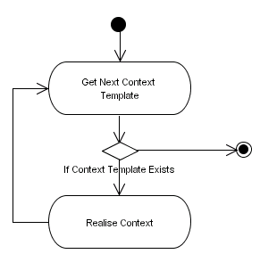
Figure 11 Retrieve Context Templates

Issues
The issues associated with the Activity Diagram are not known at this stage.

Requirements
A device will contain zero or more Context Templates that semantically describe in which contexts the device and the services it provides can be used. This process must load each of these Context Templates and realise them – in this sense realise means extract the semantic hooks that describe the services needed in a specific context and discover each of them either locally or remotely within the P2P network. One particular example of a Context Template is a Home Entertainment System whereby the device that contains this context is a DVD Player. Typically you would only want the DVD Player to be operational if all the required services needed such as Speaker Services and Visual Services have been discovered and composed with the services provided by the DVD Player, i.e. there is no point playing a movie on the DVD Player if you cannot see or hear it.

Goals/Context
Within this Activity Diagram there are a number of goals that need to be addressed, which are described below.
- Get Next Context Template: The process must retrieve all the Context Templates used by the device. This collection of Context Templates must be iterated through within this process. In the iteration process the get next context template will retrieve the next Context Template from the collection.
- Realise Context: Each of the Context Templates retrieved from the collection must be realised. A Context Template comprises a number of service descriptions, called semantic hooks, which must be used to discover required services before the device can be used in that context.

Assumptions
The assumption within this Activity Diagram is that Context Templates are described using a RDF(S) based metadata language. An ontology needs to be used in conjunction with a semantic interoperability bridge to resolve conflicts between different vocabularies.

Scenario/Steps
This process begins by loading all the Context Templates used by the device to form a collection. This collection is iterated through and each Context Template is processed in turn and the semantic hooks it contains are realised. The semantic hooks, which are service requests, are extracted and a corresponding Peer Service is either discovered locally or remotely within the P2P network.

Extensions
No extensions to the details defined above are known at this stage.

Activity Diagram: Realise Context Template

Description
This Activity Diagram illustrates how all the Context Templates a particular device has are realised. The Activity Diagram is illustrated in Figure 12.
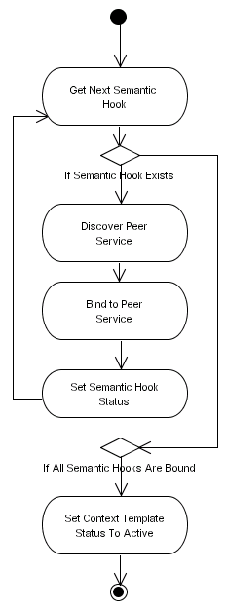
Figure 12 Realise Context Template

Issues
The issues associated with the Activity Diagram are not known at this stage.

Requirements
This process must iterate through all the semantic hooks contained in a Context Template and try to discover Peer Services either locally or remotely within the P2P network. If a semantic hook cannot be resolved, i.e. a service cannot be discovered then the semantic hook within the Context Template must be marked as inactive. If a Peer Service is found then it must be bound to the semantic hook – this results in a Peer Service object being created. This process continues until all the semantic hooks in a Context Template have been processed. If all the semantic hooks have been bound to Peer Services then the Context Template is marked as active, which means that the service can be used in that particular context – i.e. all the services required to execute the context have been discovered.

Goals/Context
Within this Activity Diagram there are a number of goals that need to be addressed, which are described below.
- Get Next Semantic Hook: A Context Template will have one or more semantic hooks that describe the services needed to use the device in this particular context. Consequently this process must iterate through all the semantic hooks and extract them.
- Discover Peer Service: Semantic hooks are described using service requests, which describe the capabilities a candidate service must provide. These service requests must be extracted from the semantic hook and used to discover peer services locally and remotely within the P2P network.
- Mark Semantic Hook as Inactive: If a semantic hook can not be resolved, i.e. a Peer Service cannot be found then it must be marked as inactive.
- Bind Service to Semantic Hook: If a Peer Service is found for a semantic hook it must be bound to the semantic hook.
- Set Context Template Status as Active: If all the semantic hooks have corresponding Peer Service bindings then this means that the device can be used in that particular context.

Assumptions
The assumption within this Activity Diagram is that Context Templates are described using a RDF(S) based metadata language. An ontology needs to be used in conjunction with a semantic interoperability bridge to resolve conflicts between different vocabularies.

Scenario/Steps
This process receives a Context Template and iterates through all the semantic hooks it contains. If a semantic hook is found, the semantic service request is extracted from the semantic hook and is used to discover a Peer Service locally or remotely within the P2P network. If a peer service cannot be found the semantic hook will be marked as inactive otherwise the service is bound to the semantic hook. If all the semantic hooks within the Context Template have corresponding Peer Service bindings then the Context Template is marked as active and the device and the services it provides can be used within that context.

Extensions
No extensions to the details defined above are known at this stage.

Activity Diagram: Discover Peer Service

Description
This Activity Diagram illustrates how Peer Services are discovered locally and remotely in the P2P network within this framework. The Activity Diagram is illustrated in Figure 13.
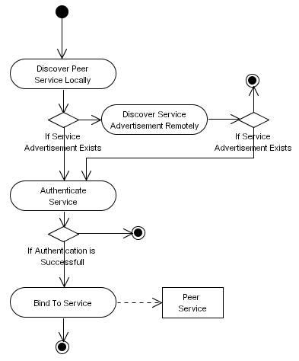
Figure 13 Discover Peer Services

Issues
The issues associated with the Activity Diagram are not known at this stage.

Requirements
This process must try to discover Peer Services locally or remotely within the P2P network. If a candidate service is discovered it must be authenticated to determine whether the service provider is trustworthy. If the service is successfully authenticated it must be bound to, and a Peer Service object instance must be created. This object instance is then returned to the caller. If the Peer Service cannot be found then the process must terminate.

Goals/Context
Within this Activity Diagram there are a number of goals that need to be addressed, which are described below.
- Discover Service Advertisement Locally: Initially this process must try to discover the Peer Service locally.
- Discover Service Advertisement Remotely: If the service cannot be found locally then this process must try to discover the Peer Service remotely within the P2P network.
- Authenticate Service: Any candidate Peer Services that are discovered must be authenticated to determine whether the service provider is trustworthy.
- Bind to Service: If a Peer Service is discovered it must be bound to and a Peer Service object instance must be created. This object must then be returned to the process initiator.

Assumptions
The framework assumes that all Peer Services will be authenticated before they are used to ensure that only services provided by trustworthy service providers are used. How the device manufacturer performs this authentication is dependent on the security policy being used, however the framework authentication interfaces must be implemented.

Scenario/Steps
This process begins by trying to discover a Peer Service locally on the device itself. If the service cannot be found locally then the device tries to find the service remotely within the P2P network. When a Peer Service is discovered it is first authenticated to determine whether the service provider is trustworthy, before it is used. If the service is successfully authenticated then the service is bound to. When a Peer Service has been found and it has been bound to.

Extensions
No extensions to the details defined above are known at this stage.

Activity Diagram: Invoke Peer Service

Description
This Activity Diagram illustrates how peer services are invoked within this framework. The Activity Diagram is illustrated in Figure 14.
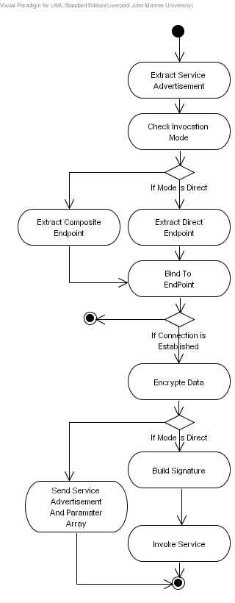
Figure 14 Invoke Peer Service

Issues
The issues associated with the Activity Diagram are not known at this stage.

Requirements
This process must begin by extracting the Service Advertisement from either a service request, received via the composite endpoint, or a semantic hook in a Context Template. When the advertisement is extracted this process must extract the invocation mode – a service can either be invoked directly or indirectly via composite services. If the connection mode is direct then the direct endpoint must be extracted and bound to. If a connection with the service cannot be established then this process must terminate. If a connection with the service has been established the signature must be built and the service must be invoked – the return value, if a value is returned, must be either processed by the service invoker or passed back up the composition chain. If the connection mode is composite this means that the service can only execute a service it provides via an intermediary service – for example the data type information may need to be converted into an alternative format. In this instance the Service Advertisement along with the required array of parameters needed to invoke the service must be passed to the service via its composite endpoint. Again if a value is returned it must either be processed by the caller service or passed back up the composition chain. Any data sent to the service once it has been bound to must be encrypted. How this is achieved is dependent on the security policy used by the device manufacturer.

Goals/Context
Within this Activity Diagram there are a number of goals that need to be addressed, which are described below.
- Extract Service Advertisement: Messages may be sent via a composite endpoint or they may be embedded within semantic hooks described in Context Templates – either method requires that the service request be extracted.
- Check Invocation Mode: The connection mode must be extracted from the service advertisement and used to determine how a connection with the required service can be established.
- Extract Endpoint: If the connection mode is direct then the direct endpoint must be extracted and used to bind to the service. If the connection mode is composite then the composite endpoint must be extracted and used to bind to the service.
- Bind to Endpoint: Endpoints provide the location of services. Services that wish to use other services must connect to these endpoints before they can invoke the methods it provides.
- Send Service Advertisement and Parameter Array: If the connection mode is composite this means that the service can only be executed via one or more intermediary services. In this instance the service advertisement and the array of required parameters are sent to the composite endpoint, where the service request is further processed.
- Build Signature: If the connection mode is direct then this means that we can directly connect to the service and execute the required method. In this instance the signature needs to be built using the operation name, the required parameters and the parameter order. This signature must then be used to invoke the required method provided by the Peer Service.
- Encrypt Data: Any data, i.e. parameter values must be encrypted before they are sent to the Peer Service. How this is achieved is dependent on the device manufacturer’s security policy.
- Invoke Service: When a signature has been built it must be used to dynamically invoke the required method.

Assumptions
How data is encrypted is dependent on the device manufacturer’s security policy. This framework does not place any constraints on how this is achieved, however the data encryption interfaces provided by the framework must be implemented.

Scenario/Steps
This process begins by extracting the service advertisement from either a message received via the composite endpoint or from a message that describes a semantic hook in a Context Template. Once the service advertisement has been extracted, the service invocation mode is extracted and used to determine whether the service can be directly invoked or invoked via an intermediary service. If the connection mode is direct then the direct endpoint is extracted else the composite endpoint is extracted. The endpoint is used to bind to the service. If a connection mode cannot be established then this process terminates. If a direct connection is established with the service then the required signature is built by extracting the method name, the required parameter names, including the type information, and the order in which the parameters must appear in the signature. This information is then used to build the signature and invoke the required method. If a composite connection is established with the service, then the service advertisement along with the parameters are sent to the composite endpoint for further processing. Before any data is sent to the service it is encrypted.

Extensions
No extensions to the details defined above are known at this stage.

Activity Diagram: Process Service Request

Description
This Activity Diagram illustrates how service requests, received either locally or from within the P2P network are processed in this framework. The Activity Diagram is illustrated in Figure 15.
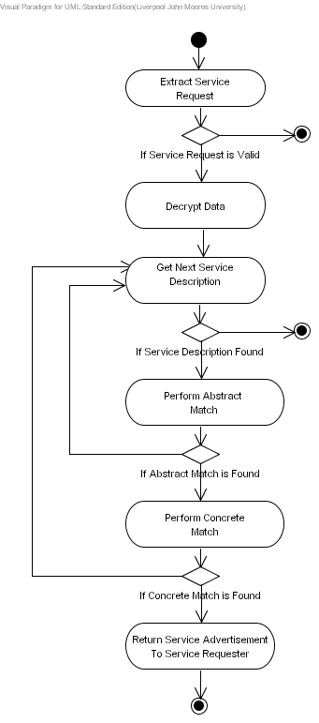
Figure 15 Process Service Request

Issues
The issues associated with the Activity Diagram are not known at this stage.

Requirements
This process must receive service request messages either locally or from within the P2P network. When a service request is received the data will be encrypted, consequently the data must be decrypted before it can be used. Service requests must be validated before they are used. The device must iterate through the service descriptions for each Peer Service the device has to determine if they match the capabilities described in the service request. The service request and a given service description must be abstractly matched – abstract matches are determined by matching the IOPEs in the service request with IOPEs in the service description. If an abstract match is found then the service description must be further processed to determine if the IOPEs, including their corresponding type information, match signatures defined in the Service Interface – this is known as concrete matching. If a concrete match is found then the IOPE descriptions described in the service request can be used to invoke a method provided by the Peer Service. When a concrete match is found the service advertisement must be returned to the service requester.

Goals/Context
Within this Activity Diagram there are a number of goals that need to be addressed depending on the particular actor involved.
- Extract Service Request: Service requests are transmitted and received within the P2P network. The service request itself is wrapped in a message object; consequently the service request must be extracted from this message object.
- Decrypt Data: Service request data will be encrypted, consequently the data must be decrypted before it can be used.
- Get Next Service Description: The device will have several Peer Services and each Peer Service will have a corresponding service description. When a service request is received this process must iterate through all the descriptions, as such each service description must be extracted.
- Perform Abstract Match: The framework provides a level of flexibility that allows services to be matched at an abstract level and/or a concrete level. The abstract matching process determines whether the IOPEs in the service request match the IOPEs in a service description – if a match is found this means that the service request describes the same behaviours as the service description.
- Perform Concrete Match: Although abstract matching allows service descriptions to be matched with service requests in terms of high level capabilities, it does not match the IOPEs in the service request with methods in a Service Interface. As such the concrete matching algorithm tries to determine if there is one single signature in the Service Interface that supports all the required IOPEs, and their associated data types, in the service request.
- Return Service Advertisement to Service Requester: If a concrete match is found then the service advertisement, which contains the service description, must be returned to the service requester.

Assumptions
How data is decrypted is dependent on the device manufacturer’s security policy. This framework does not place any constraints on how this is achieved, however the data decryption interfaces provided by the framework must be implemented.

Scenario/Steps
This process begins by extracting the service request from the message object received from the P2P network and decrypting the data it contains. This service request is then matched at an abstract and concrete level to determine if a service provided by the device matches the required capabilities described in the service request. If the service request is not valid then this process exits. If the device does not provide any Peer Services, i.e. no service descriptions can be retrieved then this process exits. The service advertisements of any concrete matches are returned to the service requester.

Extensions
No extensions to the details defined above are known at this stage.

Activity Diagram: Perform Semantic Interoperability

Description
This Activity Diagram illustrates how semantic interoperability is performed within this framework. The Activity Diagram is illustrated in Figure 16.
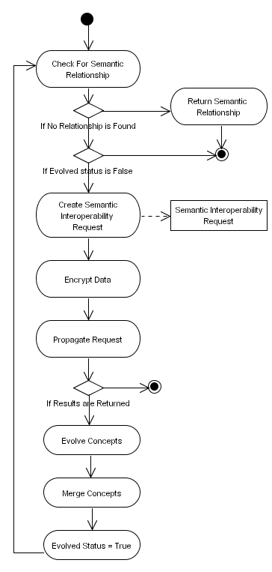
Figure 16 Perform Semantic Interoperability

Issues
The issues associated with the Activity Diagram are not known at this stage.

Requirements
This process must begin by trying to find a semantic relationship between two terms. For example an “Alsatian” is a “SubclassOf” “Dog”. In this instance the two terms are “Alsatian” and “Dog” and the relationship is “SubclassOf”. If a relationship can be found between the two terms then the relationship must be returned to the service requester. If a relationship cannot be found and the two terms have not yet been evolved then the process needs to create a semantic interoperability request that contains the two terms, and propagate it within the P2P network. This request must try to find concepts used by other devices within the network that link the two terms together. If no results are returned from the P2P network then this process is terminated. If any responses are returned then they must be evolved to extract the common terms within the returned structures in order to produce an optimal solution that captures the general consensus. For example if nine out of ten people state that an “Alsatian” is a subclass of a “Dog” then these terms including the relationship will be described in the optimal structure because there is a general consensus agreement. When the optimal structure has been evolved, it must be merged into the devices existing knowledge structure. Once the structure has been merged the status of the evolution process must be set to true – this stops this process from continually looping as we only want to try and evolve a set of terms once at any give time. Once this evolution process is complete this process will try again to find a relationship. Again if a relationship is found it must be returned to the service requester. If a relationship is not found then this process must be terminated.

Goals/Context
Within this Activity Diagram there are a number of goals that need to be addressed, which are described below.
- Check for Semantic Relationship: This process must take two terms and try to determine if a semantic relationship such as “subclassOf”, “disjointWith”, or “equivalentTo” exits that links the two terms together.
- Return Semantic Relationship: If a semantic relationship is found then the relationship must be returned to the service requester.
- Create Semantic Interoperability Request: If a semantic relationship does not exist this process must create a semantic interoperability request, which contains the two terms.
- Propagate Request: The semantic interoperability request must be propagated within the P2P network – any Peer Services capable of performing semantic interoperability will check their own internal knowledge structures to see if a knowledge structure exists that semantically links the two terms together.
- Evolve Concepts: If a peer has a knowledge structure that links the two terms together, this knowledge structure will be extracted and returned back to the service requester. There may be several knowledge structures returned therefore all the structures need to be evolved in order to extract common terms and relationships that conform to the general consensus found within all the structures received. These common terms and relationships will comprise a new optimal structure.
- Merge Concepts: The optimal structure produced during the evolutionary process must then be merged into the devices existing knowledge structures.
- Set Evolved Status: When an evolutionary process has been complete the status must be set to reflect this to ensure that this process does not continually loop.

Assumptions
How data is encrypted is dependent on the device manufacturer’s security policy. This framework does not place any constraints on how this is achieved, however the data encryption interfaces provided by the framework must be implemented.
Another assumption within this Activity Diagram is that the service requests and the service descriptions are described using RDF(S) based metadata languages.

Scenario/Steps
This process receives two terms and begins by trying to determine if a semantic hook exists that links the two terms together. If a relationship is found it is returned to the service requester. If a relationship cannot be found and the terms have not yet been evolved then a semantic interoperability request is created that contains both of the terms, which is then propagated within the P2P network. Semantic interoperability services will receive these requests and attempt to determine if their local knowledge structures contain the two terms and a semantic relationship that links the two terms together. If the terms are semantically linked then the knowledge structure is extracted and returned to the service requester. The service requester may receive several of these knowledge structures, therefore all the knowledge structures will be evolved and all the common terms and relationships will be extracted to produce an optimal structure that is said to capture the general consensus within the knowledge structures received. Once the optimal structure has been created, it is merged into the devices internal knowledge structure. When this evolutionary process is complete, again this process tries to determine if a relationship exists using the devices updated knowledge base. If a relationship is found, then it is returned to the service requester, alternatively this process is terminated.

Extensions
No extensions to the details defined above are known at this stage.

Activity Diagram: Extract Ontological Structures

Description
This Activity Diagram illustrates how ontological structures are extracted within this framework. The Activity Diagram is illustrated in Figure 17.
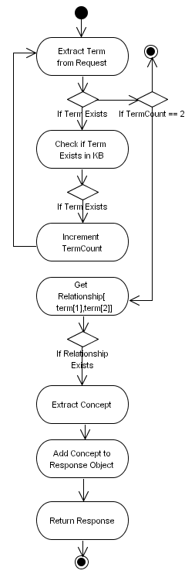
Figure 17 Extract Ontological Structures

Issues
The issues associated with the Activity Diagram are not known at this stage.

Requirements
This process begins by extracting the two terms contained in the semantic interoperability request and checking to see if they exist within the device’s local ontology. For each term that is found the TermCount variable must be incremented by one. This allows the process to determine whether the two terms in the request have been found within the devices local ontology. If the TermCount is equal to two then the process must try to extract the relationships that exist between the two terms from the devices local ontology. If at least one relationship exists then the concept surrounding the two terms must be extracted and added to a response object, which must be returned to the querying device.

Goals/Context
Within this Activity Diagram there are a number of goals that need to be addressed, which are described below.
- Extract Terms from Request: Typically the terms contained in the semantic interoperability request will be two. This step of the process must extract these two terms.
- Check if Term Exists in Knowledge Base: Each of the terms extracted from the request must be checked to see if they exist in the devices local ontology.
- Increment TermCount: For each term extracted and found in the devices ontology this process must increment the TermCount variable.
- Get Relationships: The two extracted terms must be used to determine if there are any relationships within the devices local ontology that link the two terms together.
- Extract Concept: If a relationship exists then the concept surround the two terms must be extracted.
- Add Concept to Response Object: The extracted concept must be added to a response object and returned to the querying device.

Assumptions
The assumption within this Activity Diagram is that the service requests and the ontological structures are described using RDF(S) based metadata languages.

Scenario/Steps
This process receives two terms and begins by trying to determine if a relationship exists that links the two terms together. It begins by trying to determine whether the two terms exist within the devices local ontology – if they do not exist then this process is terminated. However if the terms are found then the process tries to determine if any relationships exist within it’s ontology that link the two terms together. If at least one relationship is found the concept surrounding the two terms is extracted and added to a response object, which is then returned to the querying device.

Extensions
No extensions to the details defined above are known at this stage.

Activity Diagram: Evolve Ontological Structures

Description
This Activity Diagram illustrates how ontological structures are evolved within this framework. The Activity Diagram is illustrated in Figure 18.
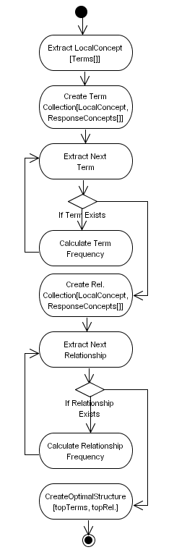
Figure 18 Evolve Ontological Structures

Issues
The issues associated with the Activity Diagram are not known at this stage.

Requirements
This process must begin by extracting the concept surrounding the terms that were initially propagated within the network as described in the previous section. Note that this may result in a zero concept because one or more of the terms may not exist in the devices ontology. Once the concept has been extracted, all the unique terms that exist in the concept extracted from the devices ontology including all the responses received from other devices within the network, must be extracted and placed into a collection. Once the collection has been created this process must loop through the collection and for each term check how many times is appears within all the structures being processed. This must result in a term frequency value. Once all the terms have been assigned a corresponding fitness value the same process must be performed for all the unique relationships that exist between all the nodes in the structures being processed. Again the relationship frequency must be calculated resulting in a relationship frequency value. Once all the terms and the relationships have been assigned fitness values the top n fittest nodes and the top n fittest relationships must be used to create an optimal structure that is said to capture the general consensus.

Goals/Context
Within this Activity Diagram there are a number of goals that need to be addressed, which are described below.
- Extract Local Concept: When several responses are received from the network this process must begin by extracting the ontology structures is has regarding the terms it is trying to evolve.
- Create Term Collection: Using the extracted ontology structure including the responses received from the network, all the unique terms must be extracted and inserted into a collection.
- Calculate Term Frequency: This term collection must be used in conjunction with each of the ontology structures being processed and a term frequency value must be assigned to each term in the collection.
- Create Relationship Collection: Using the extracted ontology structure including the responses received from the network, all the unique relationships must be extracted and inserted into a collection.
- Calculate Relationship Frequency: This relationship collection must be used in conjunction with each of the ontology structures being processed and a relationship frequency value must be assigned to each relationship in the collection.
- Create Optimal Structure: Using the top n terms and the top n relationships an optimal structure must be created.

Assumptions
The assumption within this Activity Diagram is that the service requests and the ontological structures are described using RDF(S) based metadata languages.

Scenario/Steps
This process begins by extracting the concept surrounding the terms that were initially propagated within the network as described in the previous section. Once the concept has been extracted, all the unique terms that exist in the concept including all the responses received from other devices within the network, are extracted and placed into a collection. Once the collection has been created this process loops through the collection and for each term, it checks how many times it appears within all the structures being processed. This results in a term frequency value. Once all the terms have been assigned a corresponding fitness value the same process is performed for all the unique relationships that exist between all the nodes in the structures being processed. Again the relationship frequency is calculated resulting in a relationship frequency value. Once all the terms and the relationships have been assigned fitness values the top n fittest nodes and the top n fittest relationships are used to create an optimal structure that is said to capture the general consensus.

Extensions
No extensions to the details defined above are known at this stage.

Activity Diagram: Merge Ontological Structure

Description
This Activity Diagram illustrates how ontological structures are merged within this framework. The Activity Diagram is illustrated in Figure 19.
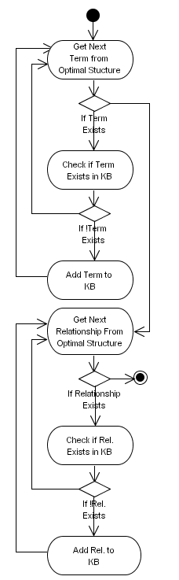
Figure 19 Merge Ontological Structure

Issues
The issues associated with the Activity Diagram are not known at this stage.

Requirements
This process must begin by retrieving each of the terms that exist in the optimal ontology structure. For each term that is extracted this process must check to see if the term already exists. It the term exists then retrieve the next term, else add the term to the devices local ontology. This iteration process must continue until no terms are left in the optimal structure. When this occurs the process must be repeated for each of the relationships that exist within the optimal structure. If a relationship does not exist then this process must terminate. However if a term exists this process must check to see if the relationship already exists. If it does not then is must be added to the devices local ontology. This process must continue until all the relationships in the optimal structure have been processed.

Goals/Context
Within this Activity Diagram there are a number of goals that need to be addressed, which are described below.
- Get Next Term from Optimal Structure: This process must begin by extracting each term contained in the optimal structure.
- Check if Term Exists in Device’s Ontology: For each term extracted this process must check to see if the term exists in the devices local ontology.
- Add Term to Device’s Ontology: If the term does not exist it must be added to the devices local ontology.
- Get Next Relationship from Optimal Structure: For each of the relationships that exist between the terms in the optimal structure this process must extract each in turn.
- Check if Relationship Exists in Device’s Ontology: For each relationship extracted this process must check to see if the relationship already exists between the two terms in the devices local ontology.
- Add Relationship to Device’s Ontology: If the relationship does not exist it must be inserted into the devices local ontology.

Assumptions
The assumption within this Activity Diagram is that the service requests and the ontological structures are described using RDF(S) based metadata languages.

Scenario/Steps
This process begins by retrieving each of the terms that exist in the optimal ontology structure. For each term that is extracted this process checks to see if the term already exists in the device’s ontology. It the term exists then it is not inserted and the next term is retrieved, else the term is added to the devices local ontology. This iteration process continues until no terms are left in the optimal structure. When this occurs the process is repeated for each of the relationships that exist within the optimal structure. If a relationship does not exist then this process terminates. However if the relationship exists the process checks to see if it exists in the device‘s local ontology. If it does not then it is added to the devices local ontology. This process continues until all the relationships in the optimal structure have been processed.

Extensions
No extensions to the details defined above are known at this stage.

Activity Diagram: Perform Abstract Match

Description
This Activity Diagram illustrates how Abstract Matching is performed within this framework. The Activity Diagram is illustrated in Figure 20.
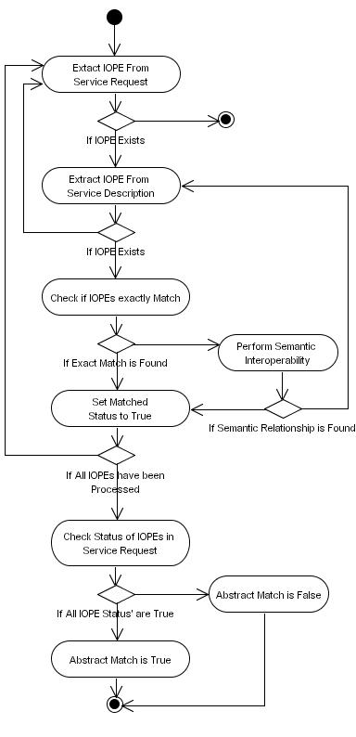
Figure 20 Perform Abstract Match

Issues
The issues associated with the Activity Diagram are not known at this stage.

Requirements
This process must determine if the capability descriptions defined in the service request match the capabilities defined in a service description at an abstract level. This process begins by iterating through each IOPE in the service request and for each IOPE extracted this process iterates through the IOPEs in the service description – this is like a loop inside a loop so that each service request IOPE is matched against every IOPE in the service description. If the service request does not contain any IOPEs then this process must be terminated. The first check in this process determines whether any two extracted IOPEs exactly match. If an exact match is found the status of the current IOPE being processed must be set to true indicating a match has been found. If an exact match cannot be found then there may be terminology differences, therefore this process must try to determine if these terms are semantically related in some way. For example the term “Film” may be equivalent to the term “Movie” even though they are syntactically different they are semantically equivalent – this must be achieved using the semantic interoperability mechanism within this framework. When all the IOPEs in the service request have been processed this process must check to see if all the IOPEs have their matched status set to true. If all the IOPEs have been matched then this constitutes and Abstract Match.

Goals/Context
Within this Activity Diagram there are a number of goals that need to be addressed, which are described below.
- Extract IOPE from Service Request: This process must iterate through all the IOPEs within a service request and extract each one in turn.
- Extract IOPE from Service Description: This process must also iterate through all the IOPEs within a particular service description and extract each one in turn.
- Check if IOPEs Exactly Match: The IOPE extracted from the service request and the IOPE extracted from the service description are checked to determine if they exactly match.
- Perform Semantic Interoperability: If the two IOPEs cannot be exactly matched then this process needs to perform semantic interoperability to determine whether the two terms are syntactically dissimilar but semantically equivalent.
- Set Matched Status: If an exact match is found then the service request IOPE status is set to true.
- Check Status of IOPEs in Service Request: When all service request IOPEs have been processed they are all checked to see if the statuses are all set to true – if all the IOPE statuses are true then an Abstract Match has been found.
- Set Abstract Match Status: Set the status at the end of the process to indicate whether an Abstract Match has been found or not.

Assumptions
The assumption within this Activity Diagram is that service requests and the service descriptions are described using a RDF(S) based metadata language. An ontology needs to be used in conjunction with a semantic interoperability bridge to resolve conflicts between different vocabularies.

Scenario/Steps
This process begins by iterating through the IOPEs in the service request and extracting each IOPE in turn. It then iterates through the IOPEs in the service description and extracts each IOPE in the service description – this is like a loop inside a loop. The two IOPEs are then compared to see if they exactly match – if an exact match is found the service request IOPE status is set to true. If an exact match cannot be determined this process calls the semantic interoperability process that determines whether the knowledge structures the device has or the structures provided by other devices within the P2P network have relationship that link the two terms together semantically. If a semantic relationship is found then the service request IOPE status is set to true, again indicating a match has been found. When all the IOPEs in the service request have been processed, this process checks to see if all the service request IOPEs statuses are set to true. If this is the case then an abstract match has been found.

Extensions
No extensions to the details defined above are known at this stage.

Activity Diagram: Perform Concrete Match

Description
This Activity Diagram illustrates how Concrete Matching is achieved within this framework. The Activity Diagram is illustrated in Figure 21.
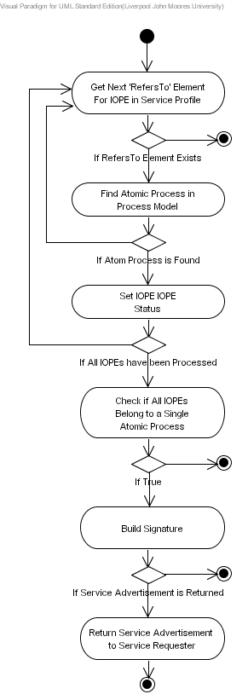
Figure 21 Perform Concrete Match

Issues
The issues associated with the Activity Diagram are not known at this stage.

Requirements
This process must iterate through all the “RefersTo” elements in the Service Profile Model and try to map them onto Atomic Processes in the Service Process Model – typically if an IOPE has a “RefersTo” element then it must belong to an Atomic Process in the Service Process Model, however all the IOPEs may belong to different Atomic Processes. If an Atomic Process is not found then this process must iterate to the next “RefersTo” element. If an Atomic Process exists then the IOPE status needs to be set to true for the current “RefersTo” element being processed. When all the “RefersTo” elements have been processed, this process must check to see if all the IOPEs, that have their status set to true, belong to a single Atomic Process. If an Atomic Process is found then the signature must be built. If the signature is successfully built then the Service Advertisement must be returned to the service requester.

Goals/Context
Within this Activity Diagram there are a number of goals that need to be addressed, which are described below.
- Get RefersTo Element for IOPE in Service Request: The service request will contain a number of IOPEs, which should have corresponding “RefersTo” elements that point to Atomic Processes in the Service Process Model. This process needs to iterate through these “RefersTo” elements and extract each one in turn.
- Find Atomic Process in Service Process Model: The “RefersTo” element must be used to locate a corresponding Atomic Process in the Service Process Model.
- Set IOPE Atomic Process Status: If an Atomic Process is found then the status of the IOPE in the service request must be set to true.
- Check if All IOPEs Belong to a Single Atomic Process: When all the “RefersTo” elements have been processed all the IOPEs that have their status set to true must be checked to see if they belong to a single Atomic Process.
- Build Signature: If a single Atomic Process is found then the Build Signature process must be called to determine if the Atomic Process can be mapped onto a concrete signature that exists in the Service Interface.
- Return Service Advertisement to Service Requester: If the Build Signature process returns a Service Advertisement it must be returned to the service requester.

Assumptions
The assumption within this Activity Diagram is that the service requests and the service descriptions are described using RDF(S) based metadata languages. An ontology needs to be used in conjunction with a semantic interoperability bridge to resolve conflicts between different vocabularies.

Scenario/Steps
This process begins by iterating through all the “RefersTo” elements in the Service Profile Model and for each element that is extracted it tries to find a corresponding Atomic Process in the Service Process Model. If no “RefersTo” elements are found then this process terminates. If an Atomic Process is discovered the status of the IOPE is set to true. When all the IOPEs in the Service Profile have been processed this process checks to see if a single Atomic Process exists that accommodates all the IOPEs with their status set to true. If an Atomic Process is found the Build Signature process is called to determine if the Atomic Process can be mapped onto a concrete signature described in the Service Interface. If the Build Signature process returns a Service Advertisement then it is returned to the service requester.

Extensions
An important requirement within this framework is the provision to resolve matching conflicts that occur. If the Concrete Matching Algorithm successfully maps the IOPEs in the service request with signatures in the Service Interface but encounters data type conflicts it must try to resolve these conflicts using intermediary services that can explicitly provide data type conversion services. Contrary to this requirement there may be instances when converting the data type is insufficient and rather the software to achieve this must be downloaded. For example a device may choose to download a particular codec to process some media format rather than converting the data stream in real-time in order to increase or maintain a high quality of service. However less capable devices may choose to outsource the processing to a more capable device.
- Activity Diagram: Build Signature

Description
This Activity Diagram illustrates how signatures are built within this framework. The Activity Diagram is illustrated in Figure 22.
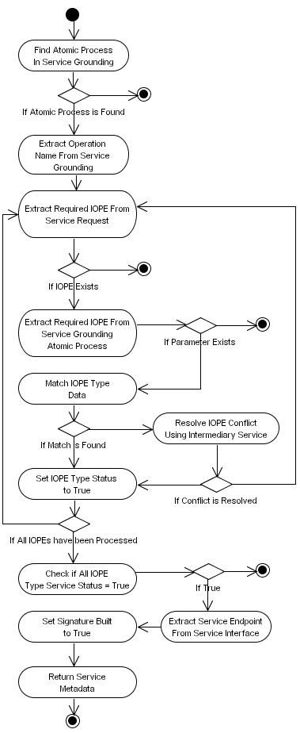
Figure 22 Build Signature

Issues
The issues associated with the Activity Diagram are not known at this stage.

Requirements
This process must build a signature to determine if a concrete match is found – if the signature can be built this means that the IOPEs including their type information can be mapped onto a signature contained in the Service Interface. This process must begin by trying to find an Atomic Process in the Service Grounding Model using the Atomic Process extracted from the Service Process Model. If an Atomic Process cannot be found then this process must terminate. If an Atomic Process is found the operation name associated with the Grounding Atomic Process must be extracted – the operation name may be part of the Service Grounding Atomic Process or it may be extracted from the Service Interface via the IOPE mappings to parameters in a particular signature. Once the operation name has been extracted this process must iterate through the IOPEs in the service request and extract each IOPE in turn. When an IOPE has been extracted it must be used to extract the IOPE in the Service Grounding Atomic Process. Once these two IOPEs have been extracted the data type information for each IOPE must be matched. If the data types match then the IOPE data type status in the service request must be set to true. If a data type conflict is discovered then the conflict must be resolved using an intermediary service. If the conflict is resolved the IOPE data type status in the service request must be set to true, else the next IOPE in the service request must be extracted. When all the IOPEs in the Service Process Model have been processed, this process must check to see if all the IOPEs, including there corresponding data type information, have been matched – in this instance all the data type status values should be true. If all status values are true then the service endpoint needs to be extracted from the Service Interface and the Signature Built status needs to be set to true to indicate a concrete match has been found. In this instance the metadata is returned to the service requester. If any status values are false then no concrete match has been found and this process terminates.

Goals/Context
Within this Activity Diagram there are a number of goals that need to be addressed, depending on the particular actor involved.
- Find Atomic Process in Service Grounding Model: The Atomic Process in the Service Process Model must be used to extract the Atomic Process in the Service Grounding Model, which maps onto a signature in the Service Interface.
- Extract Operation Name from Service Grounding Model: When the Atomic Process in the Service Grounding is extracted the operation name must either be extracted from the Atomic Process or from the signature in the Service Interface that the Atomic Process is mapped to.
- Extract Required IOPE from Service Request: The required IOPE must be extracted from the service request that exists in the Atomic Process in the Service Process Model, including its associated data type information. This will be used to determine if there are any data type conflicts between the IOPE data type and the parameters used in a service signature.
- Extract Required IOPE From Service Grounding Atomic Process: The required IOPE must be extracted from the Atomic Process in the Service Grounding Model, including its associated data type information.
- Match IOPE Type Data: The two extracted IOPEs will be matched to see if they are compatible or if any conflicts occurred.
- Resolve IOPE Conflict Using Intermediary Service: If a data type conflict is encountered then this must be resolved by trying to discover an intermediary service that can convert the conflicting data type to the required data type.
- Set IOPE Type Status to True: If the two IOPEs are successfully matched then the Atomic Process IOPE type status must be set to true to indicate a match was found.
- Check if All IOPE Type Status = True: A check must be made to determine if all the required IOPE type statuses are set to true – this being the case then this means that a concrete match has been found.
- Extract Service Endpoint from Service Interface: If a concrete match has been found then the endpoint where the service can be bound to must be extracted from the Service Interface.
- Extract Parameter Order: The parameter order must be extracted from the Service Interface. This will be used to place the parameters in the correct order.
- Build Signature: Using the operation name, the parameters and the parameter order the signature must be built.
- Set Signature Built Status: If the signature is successfully built then the status of the Build Signature must be set to true indicating a concrete match has been found.
- Return Service Metadata: All the metadata, which will include information regarding the intermediary services being used, must be returned back to the service requester.

Assumptions
The assumptions for this Activity Diagram are not clear at this stage of the design

Scenario/Steps
This process uses an Atomic Process extracted from Service Process Model to locate an Atomic Process in the Service Grounding Model. If this Atomic Process is located the operation name is extracted. The process then iterates through all the matched IOPEs in the service request and extracts each one in turn. If the IOPE exists then the required IOPE is extracted from the Service Grounding Atomic Process. If the IOPE exists then the two extracted IOPE data types are matched. If a match cannot be found the conflict is resolved using an intermediary service. If a match is found or the data type conflict has been resolved then the IOPE type status in the service request must be set to true. If all the required IOPEs and their associated data types have been matched then the endpoint for the service is extracted from the Service Interface along with the parameter order. Once these values have been extracted the Build Signature status is set to true and the service metadata is returned to the service requester, which will include information regarding any intermediary services that are required.

Extensions
No extensions to the details defined above are known at this stage.

Activity Diagram: Find Intermediary Service

Description
This Activity Diagram illustrates how intermediary services are found within this framework. The Activity Diagram is illustrated in Figure 23.
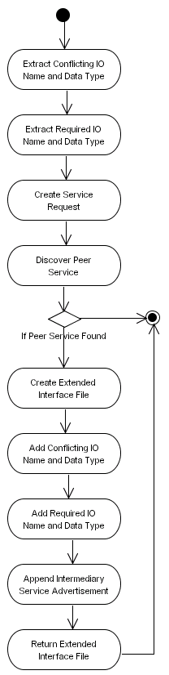
Figure 23 Find Intermediary Service

Issues
The issues associated with the Activity Diagram are not known at this stage.

Requirements
This process must extract the conflicting IOPE name and data type and the required IOPE name and data type and insert them into a newly created service request. This service request must be used to discover a Peer Service that can convert the conflicting data type into the required data type. If a Peer Service is not found then this process must terminate. If a Peer Service is found an Extended Interface file must be created and the extracted IOPEs must be added. The service advertisement for the intermediary service being used to resolve conflicts must also be added to the Extended Interface file. Once this has been done the Extended Interface file must be returned to the service requester.

Goals/Context
Within this Activity Diagram there are a number of goals that need to be addressed, depending on the particular actor involved.
- Extract Conflicting IO Name and Data Type: The conflicting IOPE must be extracted from the service request, which includes its name and data type.
- Extract Required IO Name and Data Type: The required IOPE name and data type needs to be extracted from the service description.
- Create Service Request: A new service request must be created that takes as input the conflicting IOPE name and data type and generates the required IOPE name and data type as output.
- Discover Peer Service: The newly created service request must be propagated within the P2P network in order to find the required intermediary service.
- Created Extended Interface File: If a Peer Service is found that can resolve the conflict then an extended interface must be created.
- Add Conflicting IO Name and Data Type: The details regarding the conflicting IOPE must be added to the Extended Interface file.
- Add Required IO Name and Data Type: The details regarding the required IOPE needed to resolve the conflict must be added to the Extended Interface file.
- Append Intermediary Service Advertisement: The service advertisement for the intermediary service must also be added to the Extended Interface file.
- Return Extended Interface File: When all the information has been added to the Extended Interface file it must be returned to the service requester.

Assumptions
The assumptions for this Activity Diagram are not clear at this stage of the design

Scenario/Steps
This process begins by extracting the conflicting IOPE name and data type and the required IOPE name and data type. A new service request is created and the two IOPEs are inserted into the service request, which is then propagated within the P2P network. If a Peer Service is discovered an Extended Interface file is created and the two IOPEs, including the service advertisement returned from the intermediary service, are appended to the Extended Interface file, which is then returned to the service requester.

Extensions
No extensions to the details defined above are known at this stage.

Activity Diagram: Device Capability Matching

Description
This Activity Diagram illustrates how device capability profiles contained in service requests are matched with device capability advertisements located on the device, within this framework. The Activity Diagram is illustrated in Figure 23.
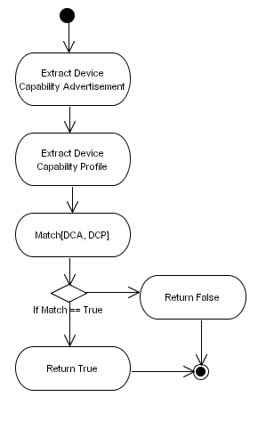
Figure 24 Device Capability Matching

Issues
The issues associated with the Activity Diagram are not known at this stage.

Requirements
This process must begin by extracting the device capability advertisement from the device currently processing a service request. Once the device capability advertisement has been loaded, this process must extract the device capability profile from the service request and load it. Once this capability models have been loaded they must be pasted to the Device Capability Matcher, which must return a value of true or false indicating whether the device has the required capabilities to execute the services it provides based on the requirements defined in the device capability profile contained within the service request.

Goals/Context
Within this Activity Diagram there are a number of goals that need to be addressed, depending on the particular actor involved.
- Extract Device Capability Advertisement: When a service request is received the devices local capability advertisement must be loaded.
- Extract Device Capability Profile: Once the devices local capability model has been loaded this process must extract the device capability profile from the service request.
- Match Capability Models: Once both models have been loaded then must be passed to the Device Capability Matcher, which returns true or false depending on the capability value calculated – if the value calculated for the device capability advertisement is equal to or higher than the value calculated for the device capability profile then a value of true must be returned else a value of false must be returned.

Assumptions
The assumptions for this Activity Diagram are not clear at this stage of the design

Scenario/Steps
This process begins by extracting the device capability advertisement from the device currently processing a received service request. Once the device capability advertisement has been loaded, this process extracts the device capability profile from the service request and loads it. Once both capability models have been loaded they are pasted to the Device Capability Matcher, which returns a value of true or false indicating whether the device has the required capabilities to execute the services it provides, based on the requirements defined in the device capability profile contained within the service request.

Extensions
No extensions to the details defined above are known at this stage.

Activity Diagram: Device Capability Matching Algorithm

Description
This Activity Diagram illustrates how the device capability matching algorithm works within this framework. The Activity Diagram is illustrated in Figure 23.
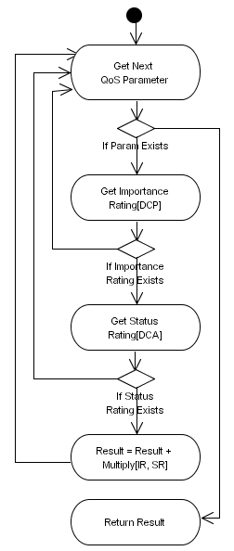
Figure 25 Device Capability Matching Algorithm

Issues
The issues associated with the Activity Diagram are not known at this stage.

Requirements
This process must loop through all the quality of service parameters used – the default parameters within this framework relate to hardware, software and networking, however these may be extended to include custom parameters deemed important to the device manufacturer. For each parameter extracted this process must extract the importance rating for the parameter from the device capability profile. If the rating does not exist then the next parameter must be extracted and this process repeated again, however if it exists this process must extract the status rating from the device capability advertisement. Again if the rating does not exist then the next parameter must be retrieved. Once the importance rating and the status rating have been extracted for a particular parameter, they must be multiplied together and added to the overall quality of service result. Once all the parameters have been processed the result must be returned to the querying process.

Goals/Context
Within this Activity Diagram there are a number of goals that need to be addressed, depending on the particular actor involved.
- Get Next QoS Parameter: This process must loop through a collection of pre-defined quality of service parameters and process the remaining steps in turn.
- Get Importance Rating: The importance rating for the QoS parameter must be extracted from the device capability profile.
- Get Status Rating: The status rating for the QoS parameter must be extracted from the device capability advertisement.
- Multiply QoS Ratings: The importance rating must be multiplied by the status rating and added to the overall result
- Return Result: Once all the QoS parameters have been processed the result must be returned to the querying process. This result indicates the overall QoS value for the devices capabilities.

Assumptions
The assumptions for this Activity Diagram are not clear at this stage of the design

Scenario/Steps
This process loops through all the quality of service parameters used and for each parameter extracted this process extracts the importance rating for the parameter from the device capability profile. If the rating does not exist then the next parameter must be extracted and this process repeated again. If it exists this process must extract the status rating from the device capability advertisement. Again if the rating does not exist then the next parameter is retrieved and processed. Once the importance rating and the status rating have been extracted for a particular parameter, they are multiplied together and added to the overall quality of service result. Once all the parameters have been processed the result is returned to the querying process.

Extensions
No extensions to the details defined above are known at this stage.

Activity Diagram: Encrypt Data

Description
This Activity Diagram illustrates how data is encrypted and decrypted within this framework. The Activity Diagram is illustrated in Figure 26.
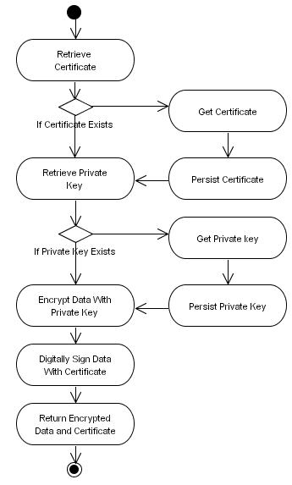
Figure 26 Encrypt Data

Issues
The issues associated with the Activity Diagram are not known at this stage.

Requirements
This process must retrieve a certificate from the devices persistent storage, which must be used to identify the device. If a certificate does not exist then one must be obtained. The framework does not place any constraints on how this is achieved, i.e. the device could be its own certificate authority or a certificate could be obtained from some third party certification authority. If a new certificate is obtained then it must be persisted. A private key must also be retrieved, which will be used to encrypt the data. Again if a key is not found then one must be obtained. If a new key is obtained then it must be persisted. If the certificate and the private key are successfully retrieved the data must be encrypted using the private key and the encrypted data packet must be digitally signed using the certificate. The encrypted data, including the certificate must then be returned to the service requester.

Goals/Context
Within this Activity Diagram there are a number of goals that need to be addressed depending on the particular actor involved.
- Retrieve Certificate: A certificate, used for digitally signing encrypted data packets, must be retrieved from the devices persistent storage.
- Get Certificate: If the device does not have a certificate then one must be obtained either from the peer itself or from some third party certification authority.
- Persist Certificate: If a new certificate is obtained then it must be persisted for future use.
- Retrieve Private Key: A private key must be used for encrypting data packets. As a result the key must be retrieved before this can occur.
- Get Private Key: If the device does not have a private key then one must be obtained.
- Persist Private Key: If a new private key is obtained then it must be persisted for future use.
- Encrypt Data with Private Key: The private key must be used to encrypt the data packets before they are transmitted within the P2P network.
- Digitally Sign Data with Certificate: When the data packet has been encrypted, it must be digitally signed using the certificate.
- Return Encrypted Data and Certificate: The encrypted data including the certificate must be returned to the service requester.

Assumptions
The assumptions for this Activity Diagram are not clear at this stage of the design

Scenario/Steps
This process begins by retrieving the certificate for digitally signing data and a private key is used to encrypt the data. It the certificate or the key does not exit then they will be obtained and persisted on the device. Before any data is transmitted within the P2P network it is encrypted using the private key and then the encrypted packets are digitally signed using the certificate. After this is complete the encrypted data including the certificate are returned to the service requester.

Extensions
No extensions to the details defined above are known at this stage.

Activity Diagram: Decrypt Data

Description
This Activity Diagram illustrates how data is decrypted within this framework. The Activity Diagram is illustrated in Figure 27.
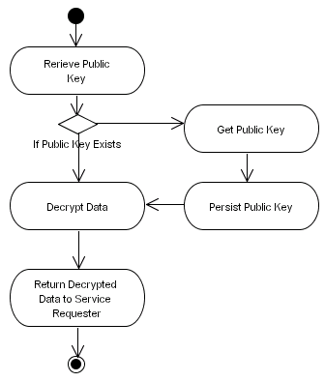
Figure 27 Decrypt Data

Issues
The issues associated with the Activity Diagram are not known at this stage.

Requirements
This process must begin by retrieving the public key from the devices persistent storage. If the public key does not exist that this process must get a new public key and persist it on the device. Once the key has been retrieved it must be used to decrypt the data. Once the data has been decrypted it must be returned to the service requester.

Goals/Context
Within this Activity Diagram there are a number of goals that need to be addressed depending on the particular actor involved.
- Retrieve Public Key: Before the data can be decrypted the appropriate key must be retrieved.
- Get Public Key: If the public key does not exist, then a new public key must be obtained.
- Persist Public Key: If a new public key has been obtained then it must be persisted on the device.
- Decrypt Data: Once the required public key has been obtained it must be used to decrypt the data packet.

Assumptions
The assumptions for this Activity Diagram are not clear at this stage of the design

Scenario/Steps
This process begins by trying to retrieve the required public key to decrypt the data. If the public key does not exist then it must be obtained and persisted on the device for future use. When a public key has been obtained it is used to decrypt the data, which is then returned to the service requester.

Extensions
No extensions to the details defined above are known at this stage.

References

